Worksheet - Reading the Chain: a First Block-Explorer Lab
Week 1, Session 2 | Assessment 2 (A2) - the weekly worksheets | You submit this yourself
Complete it in class and submit it on Moodle before you leave.
Your details (not marked)
Full name | Meqdad Muhana
Student ID | 202306213
Today's partner / group | Jassim Alawainati - 202301183
How this worksheet works
• This worksheet counts towards Assessment 2. You complete and submit it yourself, even when you work with others.
• Write your answers in your own words, and list any sources you used in Task 4.
Task 1 - From the reading
Answer the guiding questions from the structured extract.
Expected: 2-3 sentences per question.
Q1. Which fields prove control of funds, and which only describe the transfer?
The proof of control is by the signature.
The transfer described by the addresses, fee, hash, etc…
Q2. What can a block explorer never tell you about a transaction?
The identities, who made the transaction, and who is behind it.
The why too, why the transaction happened, the reason, or is it even legal or not.
Q3. Why does pseudonymity make off-chain identity checks (know your customer (KYC) / Travel Rule) necessary?
Because the addresses are codes they do not tell us the identity, so the companies must make sure who the real person, the identity.
Task 2 - Apply it (individual build task)
Now use the ideas from Task 1 to do this, in your own words:
For one real transaction you viewed, complete the does/does-not line for at least four fields: what does each field tell you, and what does it NOT tell you?
Expected: one line per field (at least four fields).
0xfd67a6554ddd58dd17b981ccc5a84fb70fffefd1c7e1caaefb5684ff10c40fa1
That is the transaction hash.
The ID of the transaction, no identity.
0.355799352 Gwei (0.000000000355799352 ETH)
That is the Gas Price.
It is the price per unit paid.
‘Success’
That is the status.
Is the transaction succeeded or failed.
2
That is the Block Confirmations.
The number of blocks produces since.
Task 3 - Group activity (your own write-up)
Your pair task: read a real transaction.
On Etherscan, walk through one transaction and one smart-contract interaction; each annotates their own in their worksheet.
• Pick a recent transaction on Etherscan and label every field.
• Pick one smart-contract interaction (a swap or a transfer) and describe what it did in plain words.
• For each, write one line on what the explorer evidence CANNOT prove.
• Keep it plain enough for a non-technical manager to follow.
Expected: complete the activity above, then write your own answer of about half a page.
Write your own answer here:
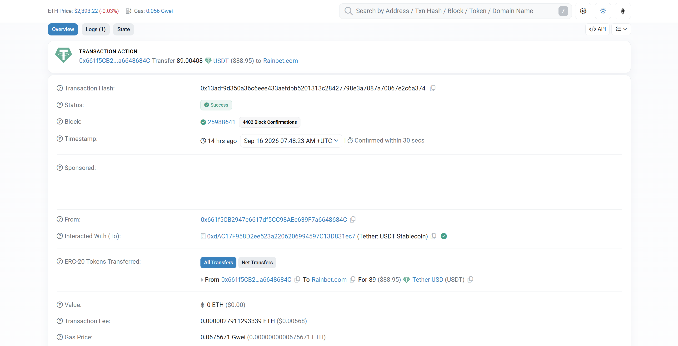
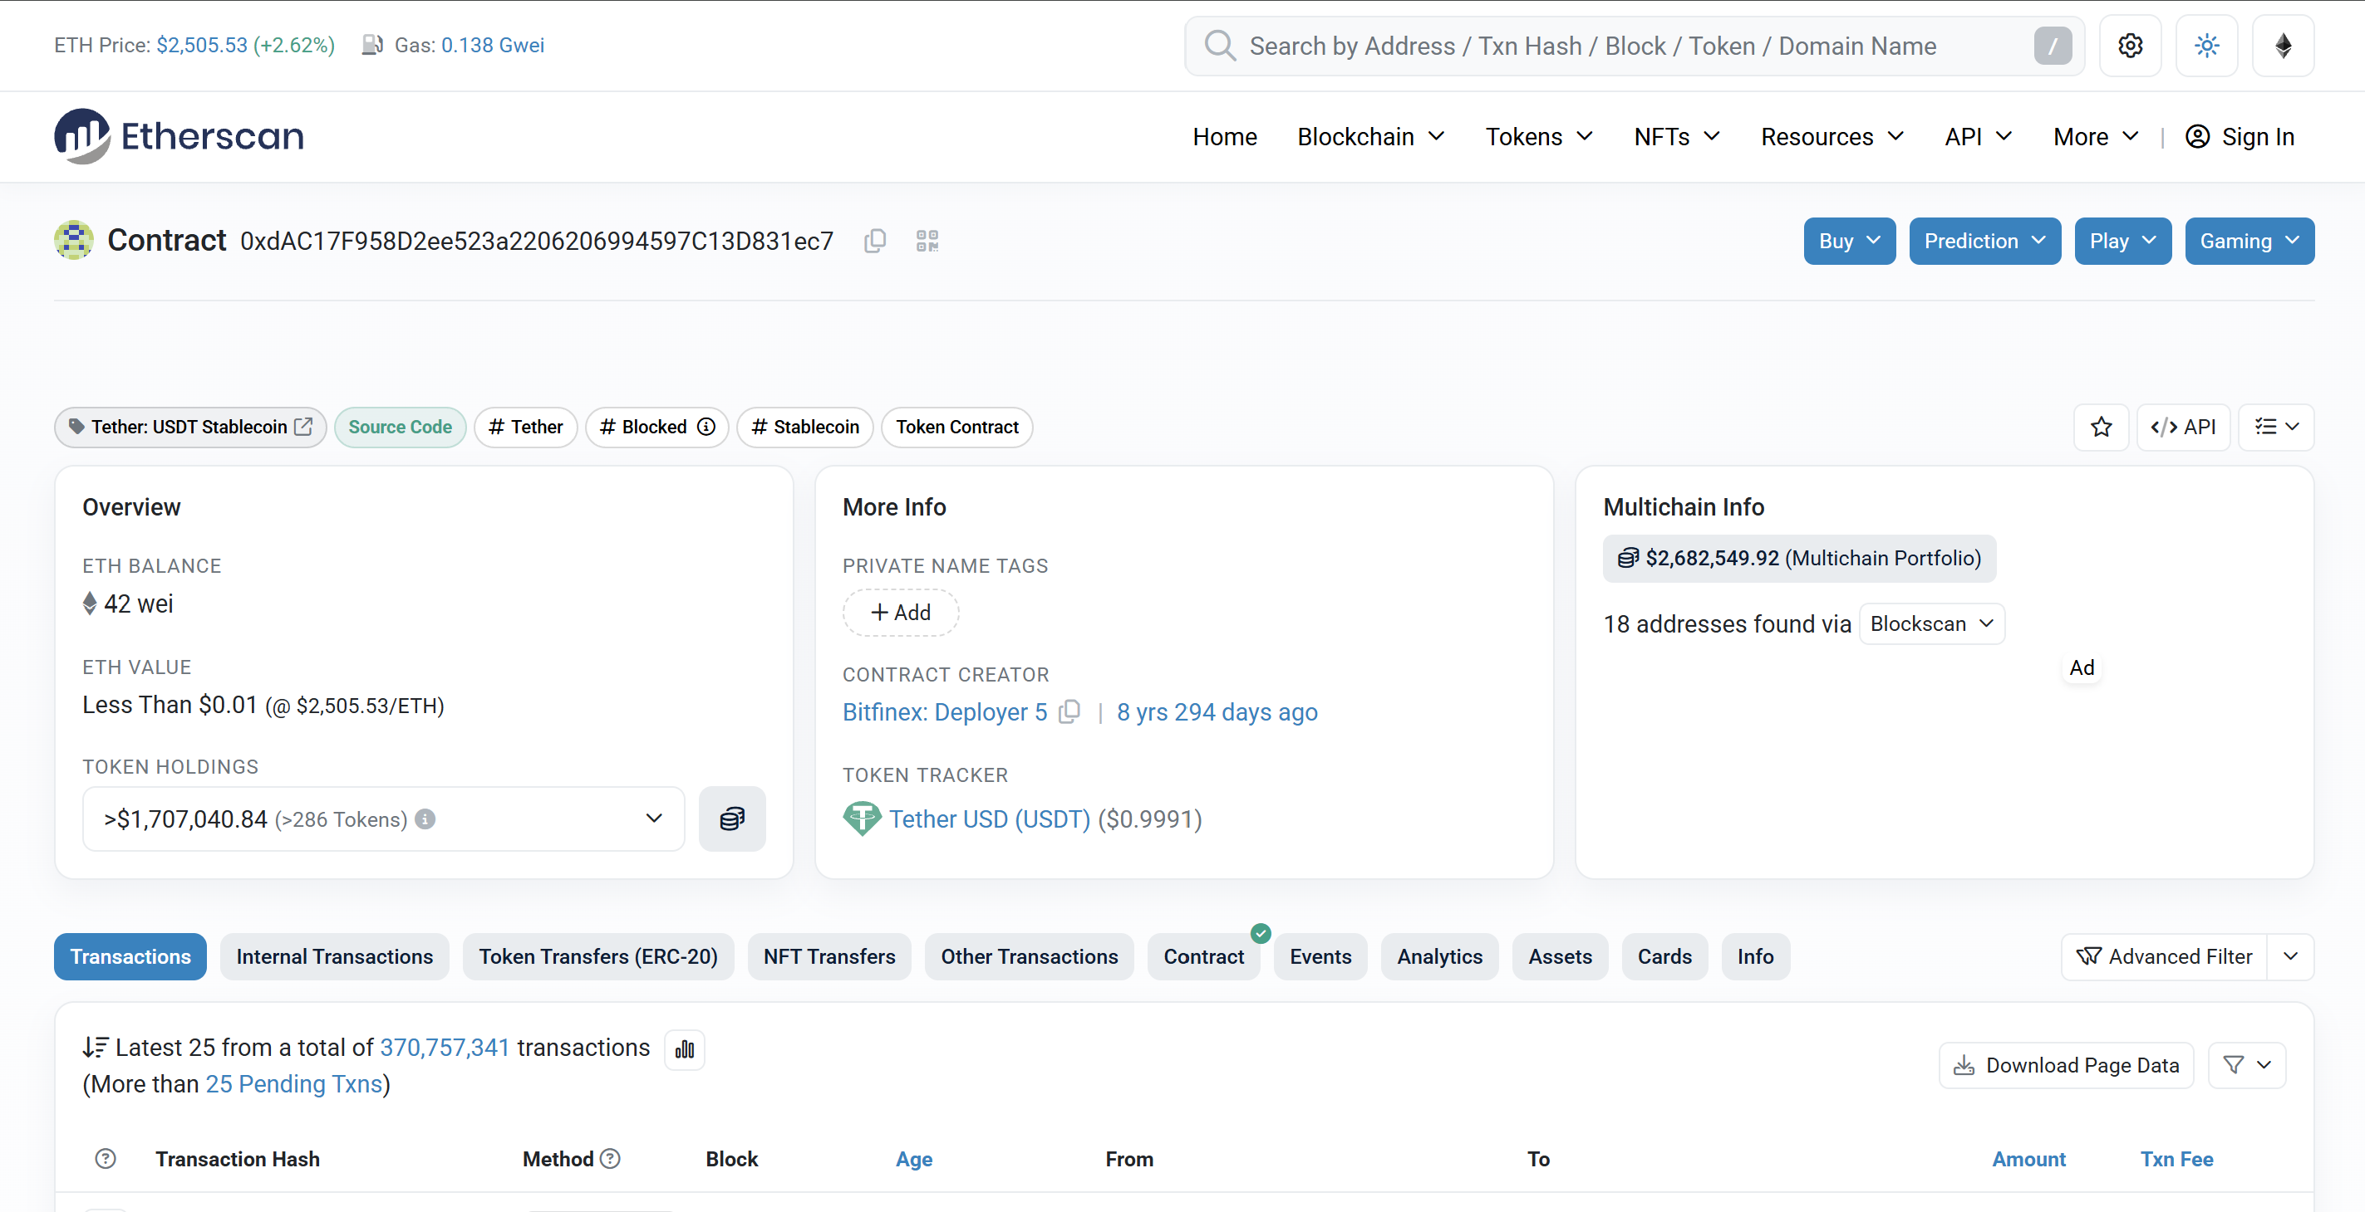
The transaction I viewed sent 89.00408 USDT from the address 0x661f5CB2…a6648684C to an address labelled Rainbet.com. Its hash is 0x13adf9d350a36c6eee433aefdbb5201313c28427798e3a7087a70067e2c6a374, which is its unique ID or fingerprint. The status shows Success, so the transaction succeeded. It was recorded in block 25988641, and the timestamp shows 16 September 2026 at 07:48:23 UTC. Lastly, the screenshot shows 4,402 confirmations, which tells me how many blocks were added after this transaction’s block, making it harder to reverse.
The value shows 0 ETH because USDT was sent. The transaction fee was 0.0000027911293339 ETH. The gas price was 0.0675671 Gwei, which tells me the price paid per unit of gas. But you can’t tell who was behind the transaction, as addresses are pseudonymous, and you can’t tell why the transfer was made.
For the smart contract, “Interacted With” shows the Tether USDT contract. The input data shows the transfer function, the receiver’s address and the amount. Basically, the sender used the contract to send the USDT to the receiver. But it cannot tell us anything off the chain, like whether Rainbet.com added the payment to the person’s account on its website.
Task 4 - Sources
Sources I used (if any) | Slides, Structured Extract, class notes.  Transaction:  https://etherscan.io/tx/0xfd67a6554ddd58dd17b981ccc5a84fb70fffefd1c7e1caaefb5684ff10c40fa1  https://etherscan.io/tx/0x13adf9d350a36c6eee433aefdbb5201313c28427798e3a7087a70067e2c6a374  Smart Contract: https://etherscan.io/address/0xdAC17F958D2ee523a2206206994597C13D831ec7
Before you submit
• Your name and student ID are filled in.
• All tasks are attempted.
• Submit this sheet before you leave today, to the Week 1 weekly worksheets link on Moodle. That same link takes both of the Week 1 weekly worksheets, one per session.
• If you need more time, finish it at home and submit to the same link by Friday 18 September 2026, 23:59. That is the deadline for both Week 1 sheets.
• Both weekly worksheets are marked together in one Week 1 marking sheet worth 1.00 percent of the course.
• You may use your notes and the session readings. Every worksheet is your own work.

